Workplace Health and Safety Workbook

Contribute to Health and Safety of Self and Others
For this actively you will participate in two work activities that contribute to the health and safety of yourself and others.

- Maintain a clean work area and check for hazards
Game developers work with expensive computer equipment, which means it its important to keep our work area clean and clear of anything that could cause damage to our equipment – like open drink containers.
Garbage, foodscraps, and other debris can attract vermin which, in addition to being unhygienic, could result in additional damage to electrical cabling and components through chewed cabling or other damage.
Clean up your work area and do a visual inspection of the external components and cables of your equipment. Ensure powerboards and electrical outlets are not overloaded, and cabling does not present a trip hazard.
Take a photo of your work area using your phone or digital camera and insert it below.
If you identified any problems, make sure to inform your trainer or supervisor.

<< insert a photograph of your work area here – ensure your work area is clean and free from hazards >>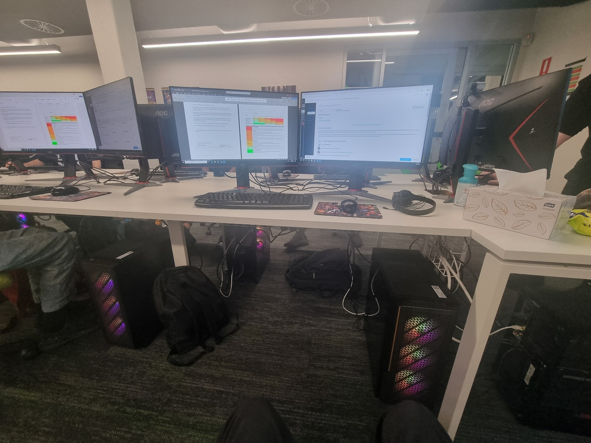

List any problems you identified here:
 | Problem or Hazard | Trainer/Supervisor  Informed | Date
1 | Loose cables | Jesse James | 16/04/26
2 | Bags if they are sticking out | Jesse James | 16/04/26

- Complete a workplace safety audit
Identify at least 3 hazards in your workspace (in addition to the example). List each hazard in the table below.
Use the Risk Matrix below to measure the risk level of each hazard.
Hazard | Consequence | Likelihood | Risk Level
Boxes on the floor | Trip hazard (minor) | Possible (3) | Medium
Liquids spilt onto electrical devices | Damage to electrical equipment (moderate) | Possible (3) | Medium
Stress environment | Decrease of mental health (Moderate) | Likely (4) | Medium
Chairs sticking out | Trip hazard (minor) | Possible (3) | Medium
Damaged cables | Electrocution (Major) | Likely (3) | High

IMPACT | LIKELIHOOD
 | Rare (1) | Unlikely (2) | Possible (3) | Likely (4) | Almost Certain (5)
Catastrophic (A) | M | M | H | C | C
Major (B) | L | M | M | H | C
Moderate (C) | L | M | M | M | H
Minor (D) | L | L | M | M | M
Insignificant (E) | VL | VL | L | L | M

Risk level | Required action
Critical | Act immediately:  The proposed task or process activity must not proceed. Steps must be taken to lower the risk level to as low as reasonably practicable using the hierarchy of risk controls.
High | Act today:  The proposed activity can only proceed, provided that:  (i) the risk level has been reduced to as low as reasonably practicable using the hierarchy of risk controls.  (ii) the risk controls must include those identified in legislation, Standards, Codes of Practice etc.  (iii) the risk assessment has been reviewed and approved by the Supervisor and  (iv) The supervisor must review and document the effectiveness of the implemented risk controls.
Medium | Act this week:  The proposed task or process can proceed, provided that:  (i) the risk level has been reduced to as low as reasonably practicable using the hierarchy of risk controls.  (ii) the risk assessment has been reviewed and approved by the Supervisor.
Low | Act this month:  Managed by local documented routine procedures which must include application of the hierarchy of controls.
Very Low | Keep a watching brief:  Although the risk level is low the situation should be monitored periodically to determine if the situation changes.

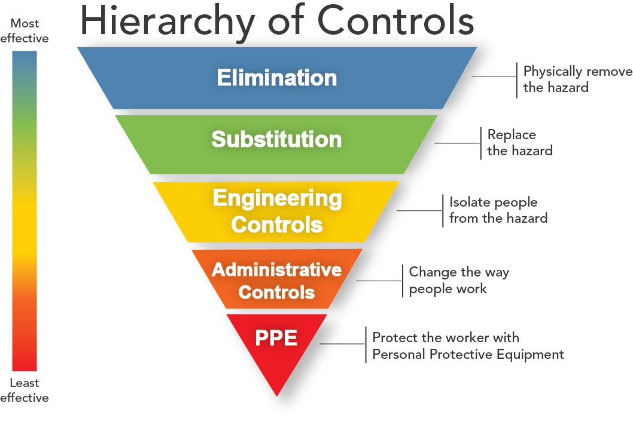
For each hazard you identified above, identify a method to control the risk of the hazard.
Try to use one of the more effective methods of control first. If that is not possible, use a less effective method.
Complete the table below, listing one or more control methods for each hazard you identified.
Hazard | Control Method
Boxes on floor (trip hazard) | Stack boxes in corner of room or put in closet
Liquids | Ensure drinks are in a sealable container and away from electrical devices.
High stress environment | Take regular breaks. Seek support. Try to minimise stress situations.
Chairs sticking out | Ensure all chairs are out of walk way and pushed into desk when not in use.
Damaged cables | Replace cable immediately.

Identify and Report One Hazard
Most workplaces have a formal method for reporting a hazard or concern.
Using one of the hazards you identified in your workplace safety audit, complete the following workplace hazard report.
If you feel the hazard you identified poses an immediate risk to the safety of yourself and other learners, give this report to student administration or the local campus Head of School. Otherwise your trainer will follow up on any safety issues.

Hazard/Incident Report Form
Use this form in your workplace to report health and safety hazards and incidents.

Hazard/Incident
Brief description of hazard/incident: (Describe the task, equipment, tools and people involved. Use sketches, if necessary. Include any action taken to ensure the safety of those who may be affected.)
The hazard is chairs sticking out. This affects all who use this workspace due a possible trip hazard.

Where is the hazard located in the workplace?
This hazard is found at desk workspaces with chairs.

When was the hazard identified? | Date: 16/04/26 | Time: 9:58
Recommended action to fix hazard/incident: (List any suggestions you may have for reducing or eliminating the problem – for example re-design mechanical devices, update procedures, improve training, maintenance work)
Ensure all chairs are out of the walkways to avoid trip hazards.

Date submitted to manager: 9:58 | Date: 16/04/26 | Time: 9:58

Action taken
Has the hazard/incident been acknowledged by management? Yes/ No
Describe what has been done to resolve the hazard/incident:
Ensuring that chairs all out of the walkways and pushed in after use.

Do you consider the hazard/incident fixed? Yes / No
Name: Jesse James | Position: Trainer
Signature:

Date: 16/04/26

Recognising the Signs
For each of the following signs that you might see around the workplace record next to each what it is referring to.
 | Wet Floor Sign: Floor is wet and slippery. Take caution.
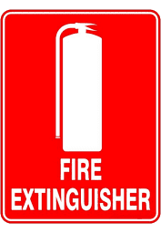 | Fire Extinguisher Sign: Notifies people of the location of fire extinguishers for use in an emergency.
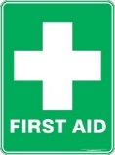 | First Aid Sign: Notifies people of the location of first aid for use if needed.
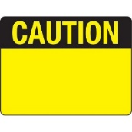 | Caution Sign: Notifies people of a possible hazard.

Fire Safety
Head to the following link and answer the following questions, it goes to a page describing the 10 measures to increasing Fire Safety.
https://www.amsj.com.au/fire-safety-measures-workplace/
List each of the measures and in your own words, briefly describe each one
- Identifying fire hazards:
Ensure items that could cause a fire are separate.

- Identifying employees at risk:
Identify those who have a higher fire risk and support them.

- Inspecting fire extinguishers:
Ensure that fire extinguishers are regularly inspected.
- Inspecting smoke detectors and fire alarms:
Ensuring that inspections are done regularly to ensure they work in an emergency.
- Checking electrical equipment:
Regularly check electrical devices for damage or faults.
- Checking evacuation routes:
Ensure that every one in the location knows the evacuation point and how to access it.
- Undergoing fire safety awareness training:
Ensure training is done to improve fire safety skills.
- Preparing emergency plans:
Ensure emergency plans exist that are accessible to all.
- Using a reliable fire protection service:
Hire a professional to certify your fire protection measures.

- Staying up to date with fire safety:
Ensure vigilance in ensuring fire safety.

How often do fire extiguishers require internal maintenance?
Every 5- 6 years.

Now head to this final link: https://www.fire.nsw.gov.au/page.php?id=74
In your own words describe what to do in the event of a fire based on the RACE acronym
- R: Rescue others if it is safe to do so.
- A: Alert other to the fire, 000 and others in your building.
- C: If safe to do so contain the fire.
- E: If trained and safe to do so try to extinguish the fire.

